**Art Bible - Ginny’s escape**

**Setting:** 1886 / Steampunk

**Style:**

* 3D, but movement locked to 2D
* realistic textures (PBR)
* scaled real-world size, but with smaller assets build by mice (think of Tom & Jerry)

**Fonts:**

InGame: Metamorphous (Substance)

Menu: not yet defined

**Substance Set-Up**

Pre-set: Unity 5 (Metal)

Environment Map: Panorama

You have to add the Emissive and Opacity channel by hand to the Unity 5 (Metal) pre-set

Please also add an AO texture as export map to the Unity 5 (Metallic) pre-set

**Materials**

We use substance painter/designer for texturing.

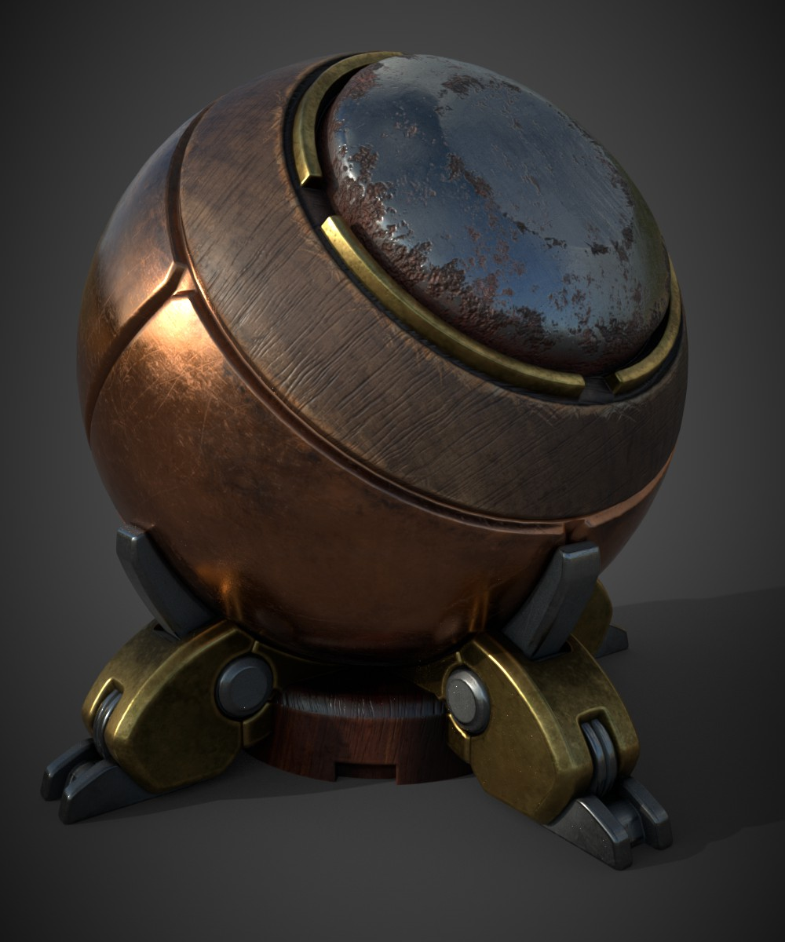

To ensure a consistent material/color scheme we created a general smart material which contains the main materials. This smart material contains the following materials:

Steel – for heavy, moving parts

Rust – Addition to Steel, if an item is heavily used

Brass – Only for ornaments and small details

Copper – for moving parts and containers

Wood – should be used as cases material for tools and other items (light/dark wood for cases, old wood for planks etc.)

Ambient Occlusion – PBR will normally generate AO in engine, but we decided to push it a little bit further and use this as an additional “dirt” layer.

This layer is always at 100% multiply on top of all other layers

**Unity Scene Set-Up**

Environment Map: Panorama

Color Space: Linear (Edit > Player Settings)

**Don’t forget the Reflection Sphere!**

**Mesh Specs**

Estimated Vert-Count (main character): ca. 10.000

Estimated Vert-Count (complex enemy/item): ca. 5000

Estimated Vert-Count (simple item): ca. 2000

File-Type: .fbx

Name: [meshname]_[map-type].tga

We try to reduce the workload as much and provide as much freedom to our level designers by using a modular setup with our model. Separate assets into sub-objects and also keep in mind that Unity can only apply one texture per object.

Larger background object will not use unique textures (we use a set of tileable texture for them) and we will use the chamfer edges + weighted normal workflow for these objects.

**Level of Detail (Mesh):**

We are **not** aiming for a realistic level of details. Only add details which are prominent or are adding to the form.

**Texture specs**

Size: 1024x1024 (512x512 for small assets)

File-Type: .tga

Name: [meshname]_[map-type].tga  
Texture maps:

* AlbedoTransparency (Albedo in RGB, Transparency in Alpha Channel)
* MetallicSmoothness (Metallis in RGB, Smoothness (inverted Roughness) in Alpha Channel)
* Normal (OpenGL)
* Emission (RGB)
* AO (Gray)

**Level of Detail (Texture):**

Since most of our key assets (e.g. the traps) are relatively small, please keep an eye on readability of additional texture details.

**Unity Folder Structure (New)**

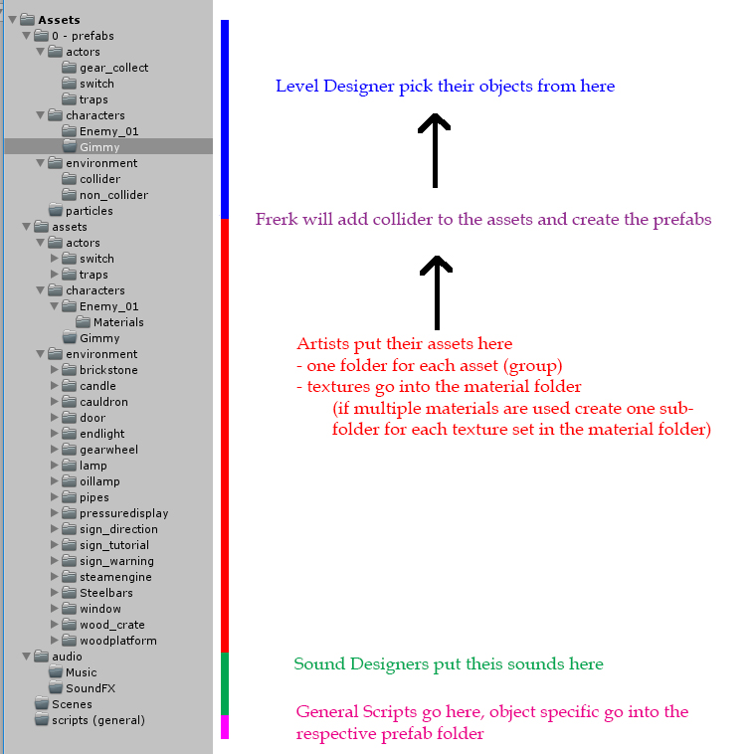

**Mouse references:**

Body

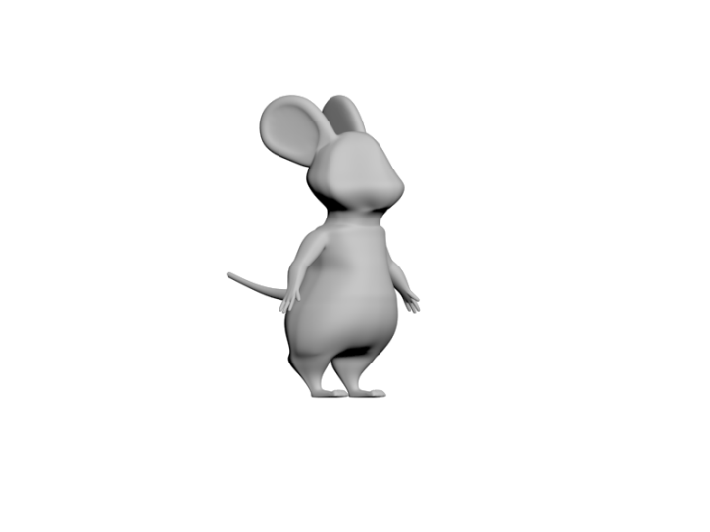

Bag

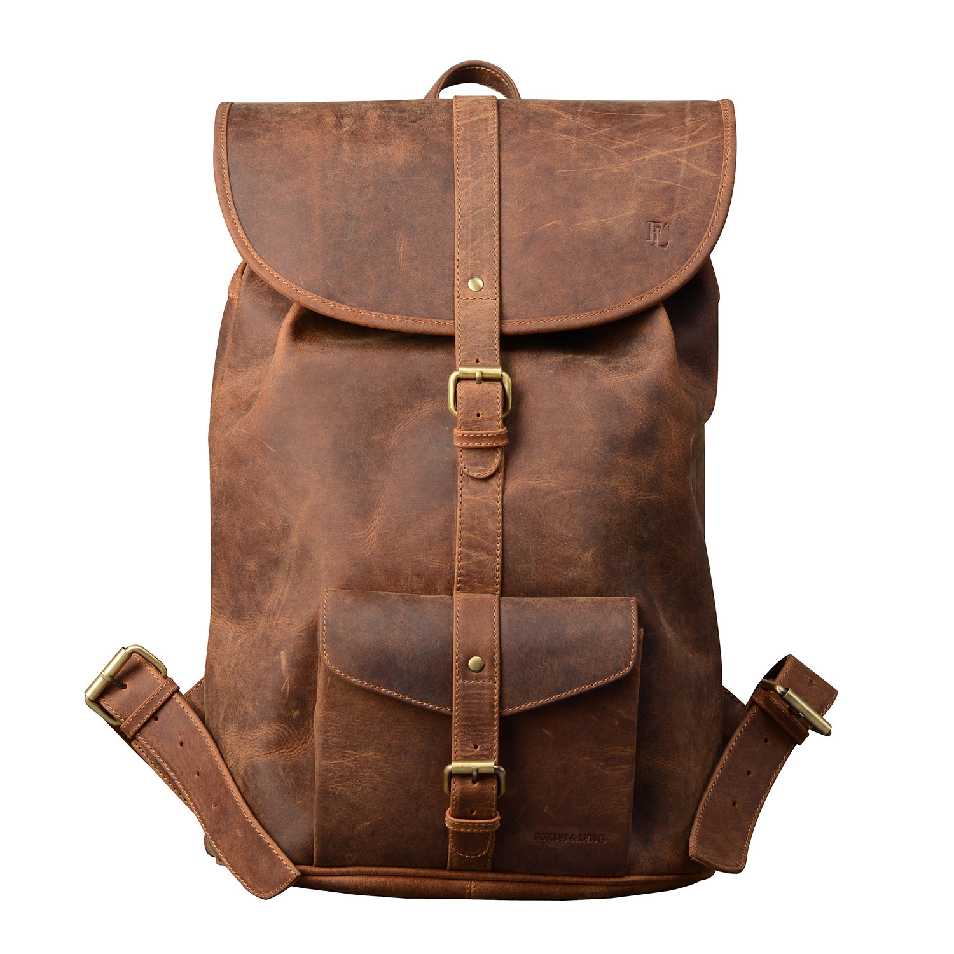

Fur

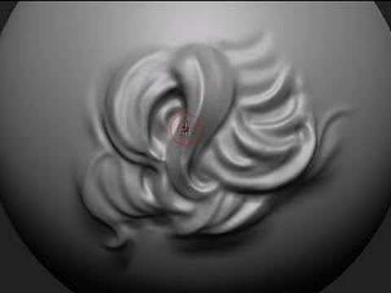

Cloth/color

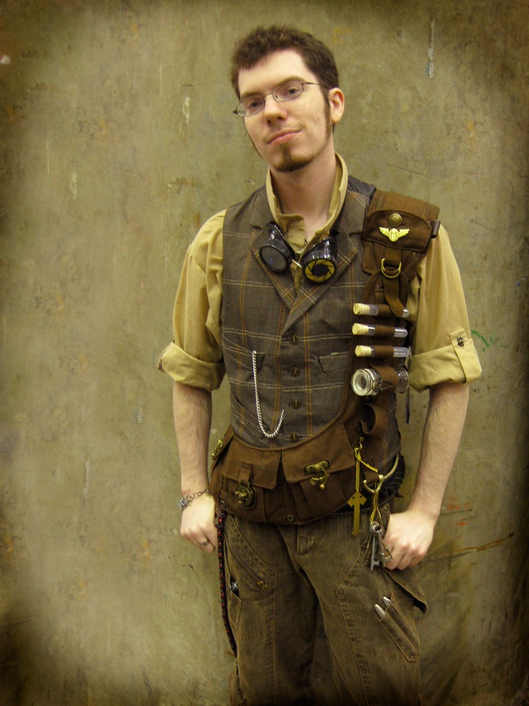

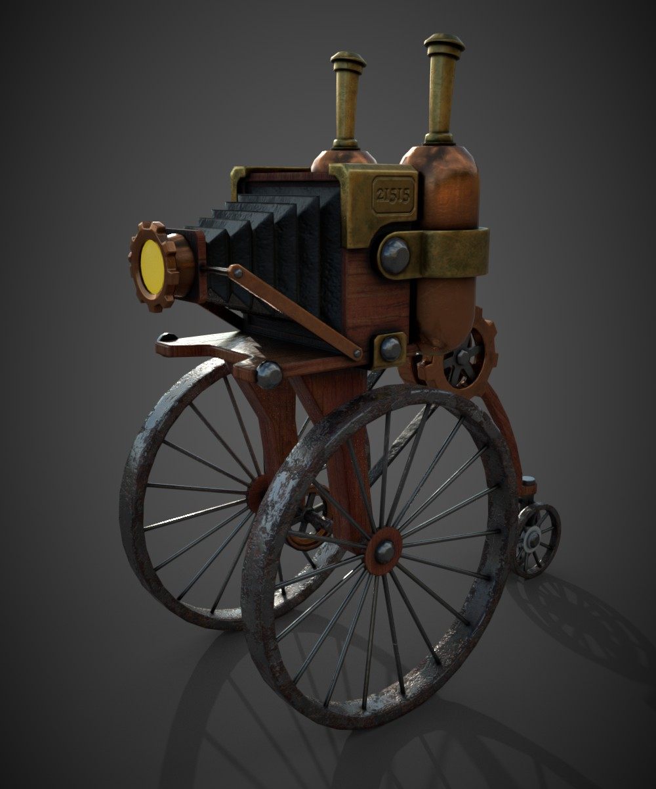**Asset references:**

